3D Engine Training

I. Create PUBEngine Project:
1. TASK: Create PUBEngine Project.
2. GUIDE:

- Create A Structure Like That:

- Add new files:

- Use Precompile Header:

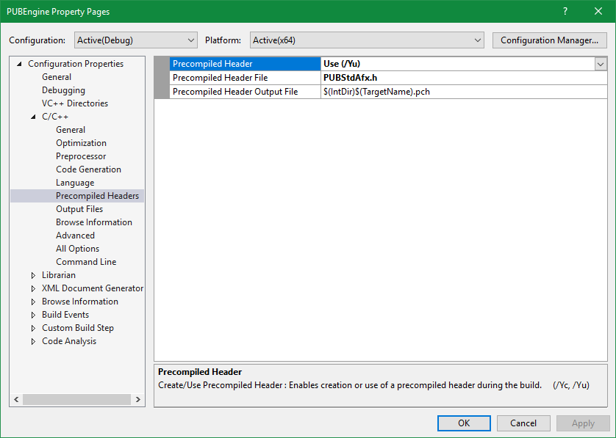
- Set Depend Project:

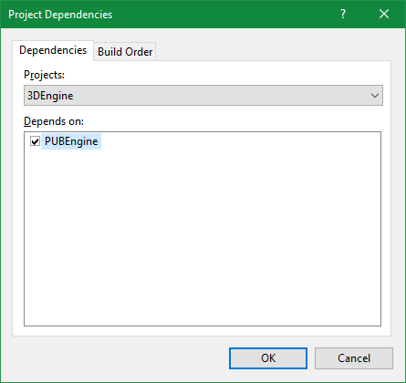

- Add "State, StateManager and Singleton" class:

- Call "StateManager" From 3DEngine Project:

- Build Win32 + Android + Call Application from JAVA.

